Project Design Phase
Solution Architecture
Date | 23 June 2026
Team ID
Project Name | UCAB – Online Cab Booking Application
Maximum Marks | 4 Marks

Solution Architecture:
Solution architecture connects the problem we are solving with the technology used to solve it. For UCAB, it shows how the user, driver, and admin interact with the system, and how each part of the application – frontend, backend, and database – works together.
- Shows the right tech stack used to solve the cab booking problem.
- Describes the structure and working of the UCAB application to the team.
- Defines the main features and modules of the application.
- Gives a clear picture of how the solution is built and delivered.

Solution Architecture Diagram: UCAB – Online Cab Booking Application
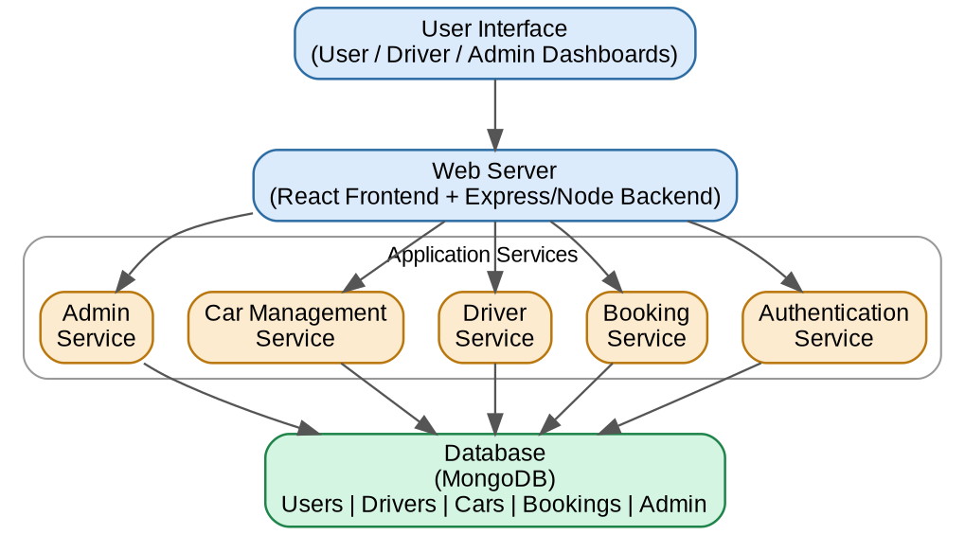
Figure 1: Architecture and data flow of the UCAB cab booking application
Reference:
https://github.com/vasanthimunduri/U-Cab

